
Cloverbuds
Memory Book

4-H Year _______

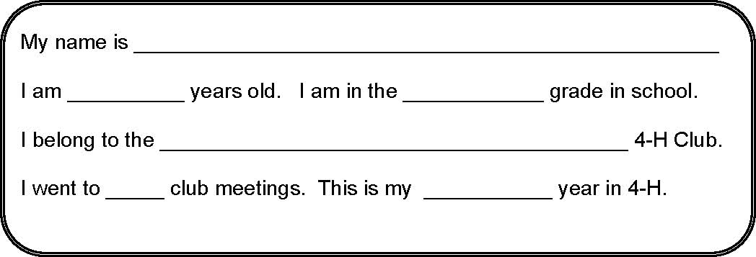

Member's Signature ___________________________________________

Parent's Signature ____________________________________________

Leader's Signature ____________________________________________

Fair exhibits for Cloverbuds are optional. They may be used to provide an opportunity to show what has been accomplished. This Memory Book may be exhibited alone or accompanied by a poster or small item made during an activity, as determined by the county. An adult may help members complete this memory book.

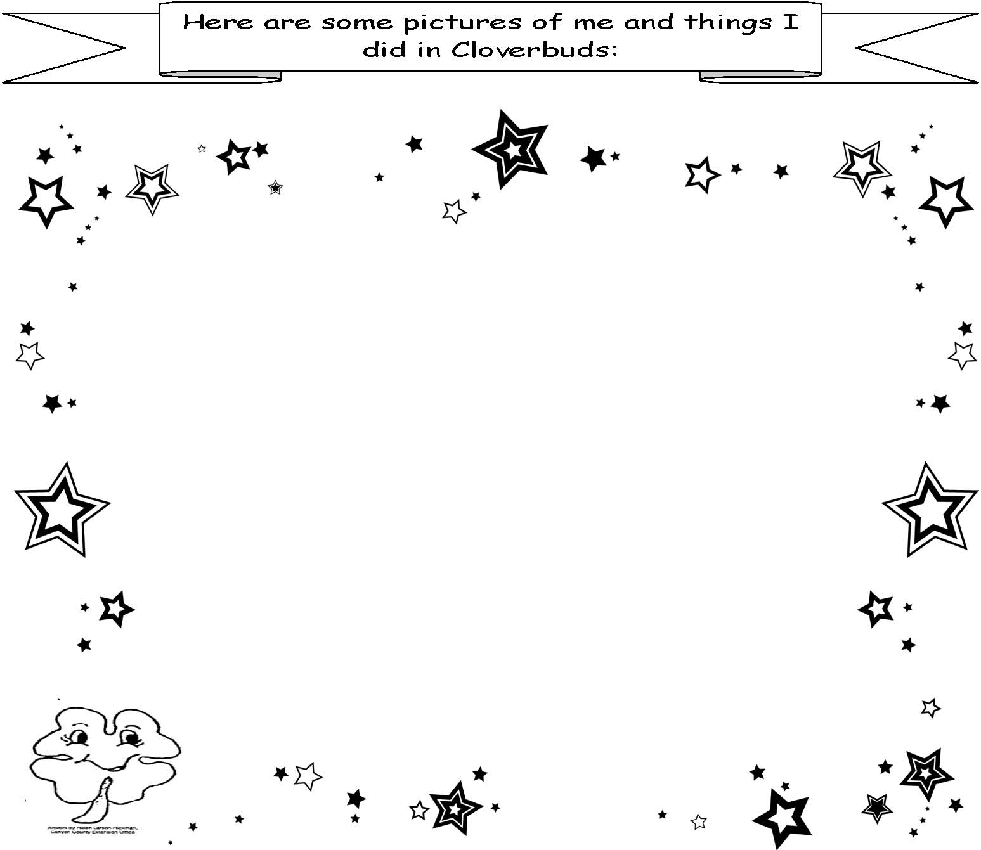The projects or activities I worked on this year were:

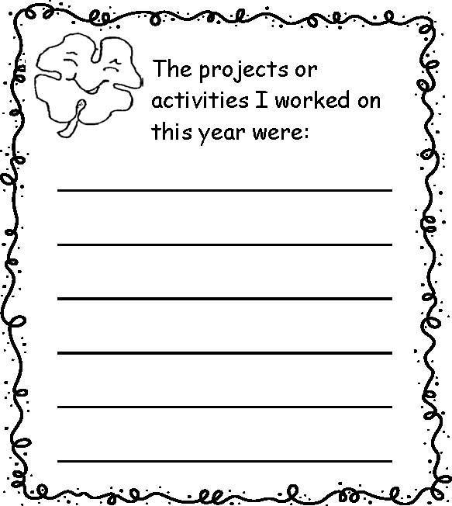In my club, I got to:


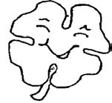

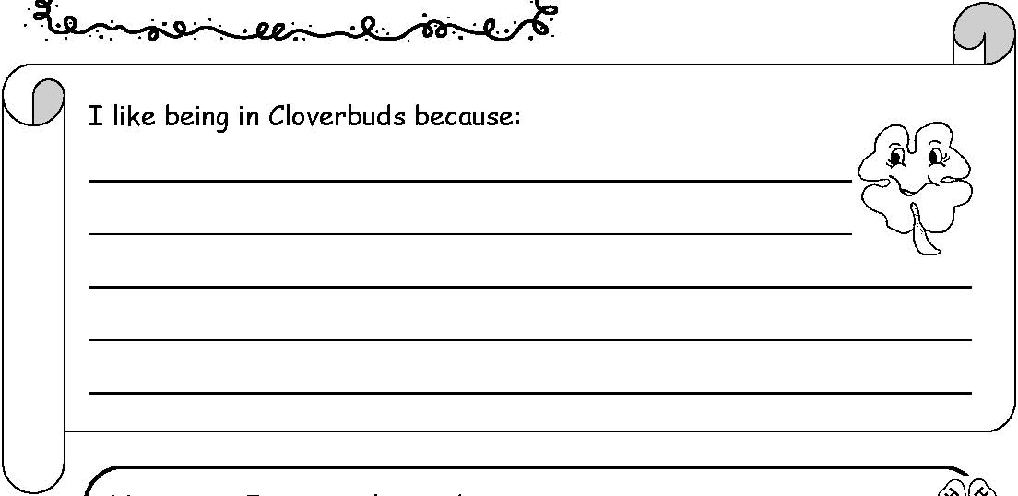

I like being in Cloverbuds because:

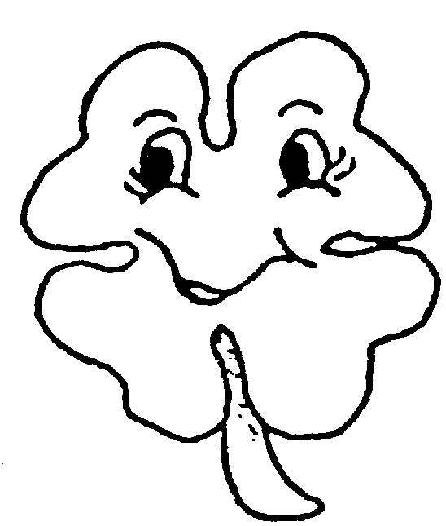

Next year I want to learn about:



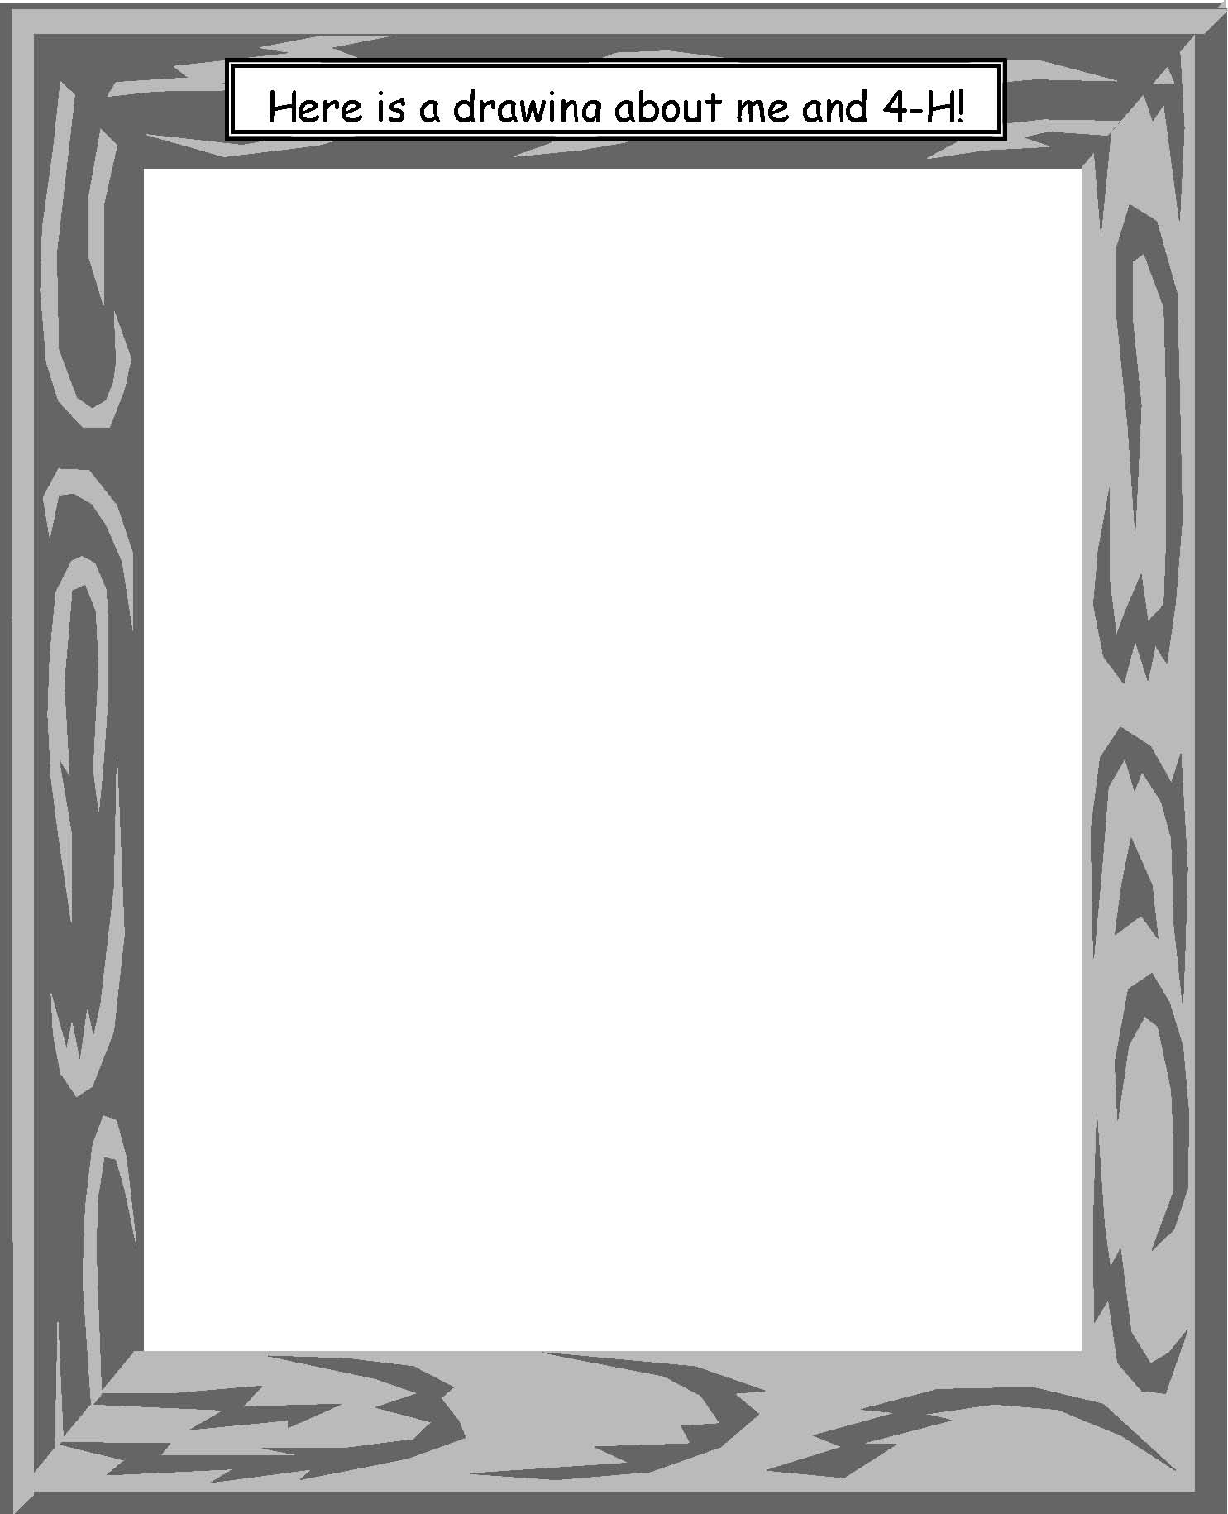

Issued in furtherance of cooperative extension work in agriculture and home economics, Acts of May 8 and June 30, 1914, in cooperation with the U.S. Department of Agriculture, Charlotte Eberlein, director of Cooperative Extension System, University of Idaho, Moscow, Idaho 83844. We offer educational programs, activities and materials without regard to race, color, religion, national origin, gender, age or disability, in accordance with state and federal laws.
Revised 11/09

