
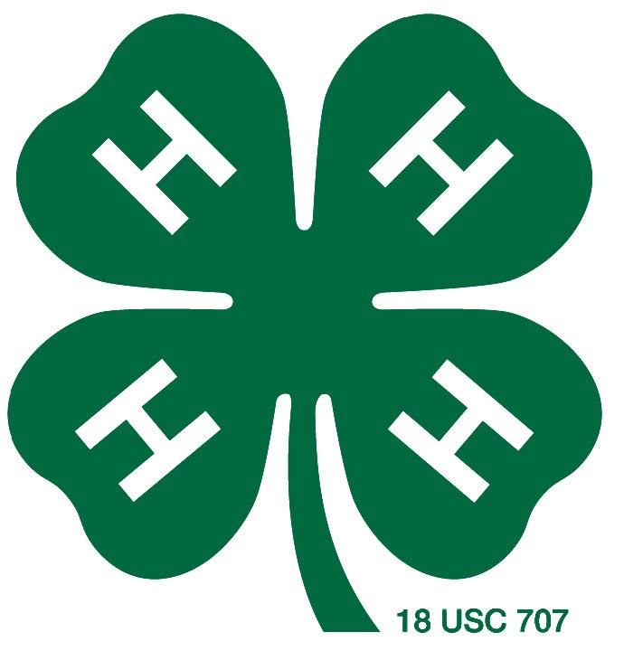
Camas County
4-H Project in a Day
Record Book

Project

Year

Name:

4-H Club:

Member’s Signature:

Leader’s Signature:

Parent’s Signature:

The University of Idaho provides equal opportunity in education and employment on the basis of race, color, religion, national origin, gender, age disability, or status as a Vietnam-era veteran, as required by state and federal laws.
Project Goals

Goal 1:
What will I do to reach this goal?

Goal 2:
What will I do to reach this goal?

My Demonstration

Title of Demonstration or Talk

What I told or did

Meeting/Activities Attended

Date Description of Activity What I learned

Expense Record

Date Paid To Description Amount

How did you do?

Take a look at your goals. How did you do? List your goals below. Using a scale from 5 to 1 rate how you feel you did on each goal. Explain why you think you deserve that rating.
Excellent Very Well OK Not So Well Very Poorly
5 4 3 2 1

Goal 1:

Rating (circle) 5 4 3 2 1

Explanation:

Goal 2:

Rating (circle) 5 4 3 2 1

Explanation:

Photographs From Your 4-H Project
(pages may be added)

4-H Story

What did you learn new from this project?

What did you like the best about this project?

What was the hardest thing to do? What would you do differently?

What new things could you do at home with what you have learned?

